9/3/2025

**API’s**

* **GET Request:**

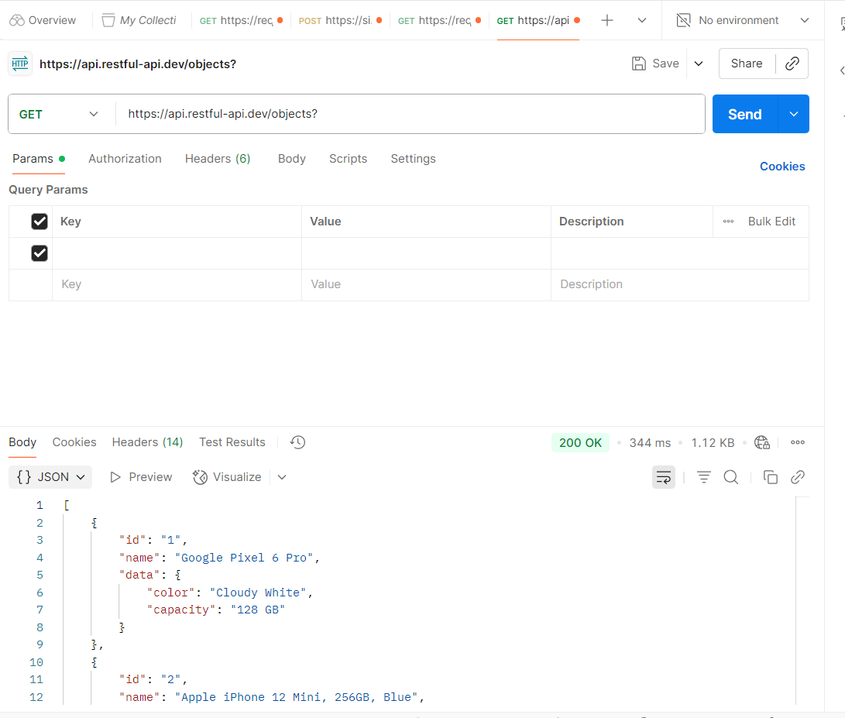

* **POST Request:**

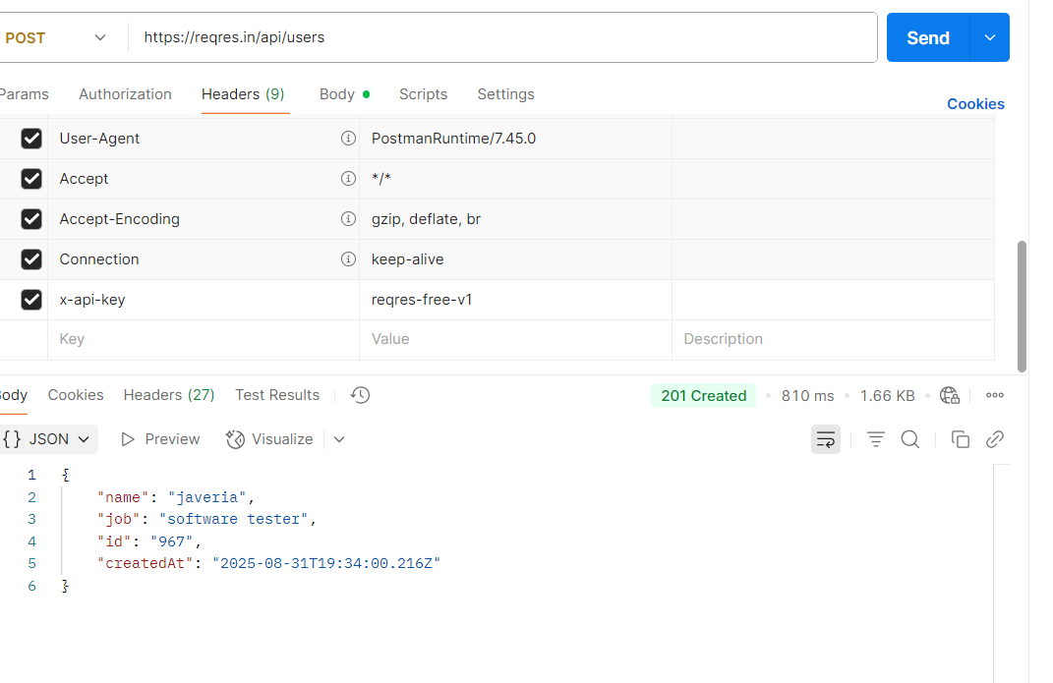

* **PUT & PATCH Request:**

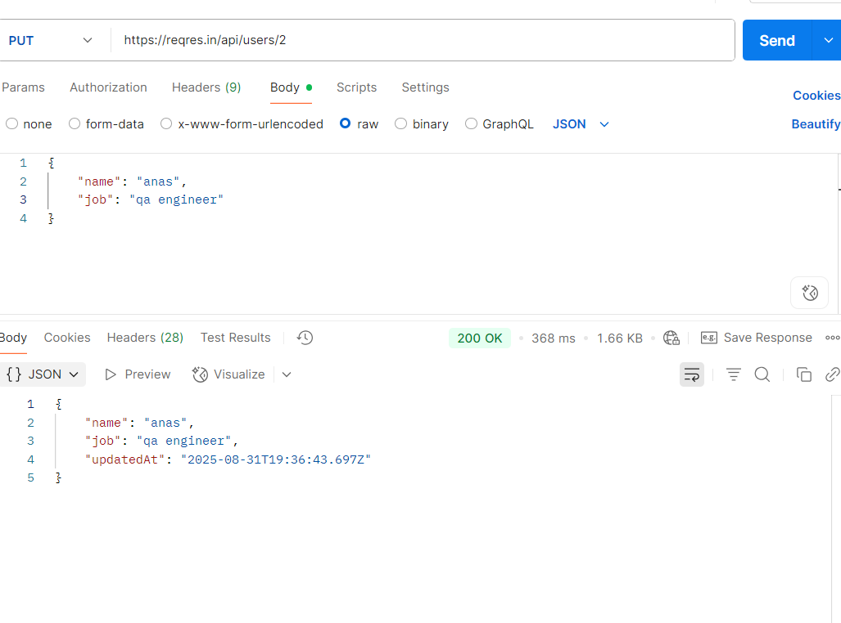

* **DELETE Request:**

